**Technical Documentation – Deploy_WES**

1. Workflow – Deploys WES Tomcat Artifacts to an Environment.

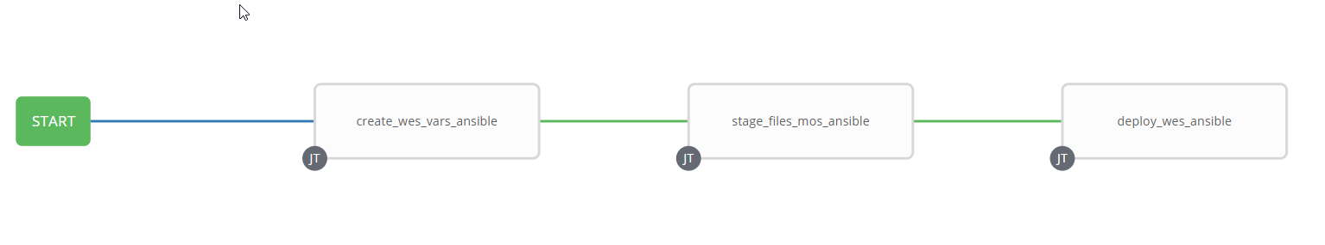

1. Survey – User Supplied Variables

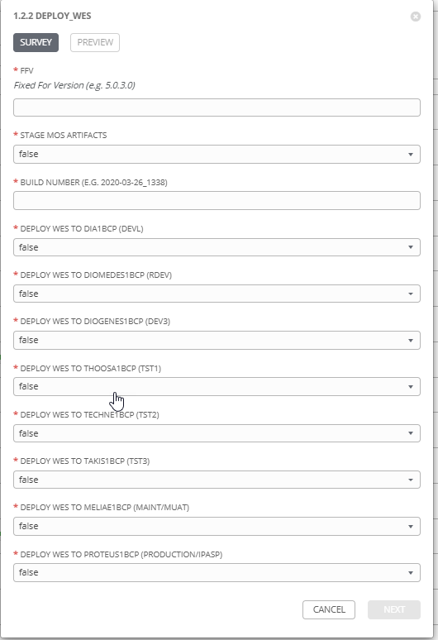

| **Survey Extra Variables** | **Prompt** | **Type** | **Description and Usage** |
| --- | --- | --- | --- |
| FFV | Fixed For Value | Text | The fixed for value for the deployment – must be for the format ###.###.###.### (i.e. 58.0.12.0). Numbers only with a maximum of 3 digits and there must be 4 sets separated with a ‘.’. Used to create staging and deployments directories. Used by all job templates in the workflow |
| STAGE | Stage MOS Artifacts | Multiple Choice Single Pick | True or false – Copies the WES Artifacts (along with ALL other artifacts in the build directory) from the MOS Build Releases Directory to the Staging folder. |
| ReleaseDir | Build Directory | Text | The /pencmw_common/MOS/releases/ subdirectory that contains the MSC artifacts |
| DEVL | Deploy WES to dia1bcp (DEVL) | Multiple Choice Single Pick | True or false – Deploys the WES Artifacts to the DEVL Environment on dia1bcp |
| RDEV | Deploy WES to diomedes1bcp (RDEV) | Multiple Choice Single Pick | True or false – Deploys the WES Artifacts to the RDEV Environment on diomedes1bcp |
| DEV3 | Deploy WES to diogenes1bcp (DEV3) | Multiple Choice Single Pick | True or false – Deploys the WES Artifacts to the DEV3 Environment on diogenes1bcp |
| TST1 | Deploy WES to thoosa1bcp (TST1) | Multiple Choice Single Pick | True or false – Deploys the WES Artifacts to the TST1 Environment on thoosa1bcp |
| TST2 | Deploy WES to techne1bcp (TST2) | Multiple Choice Single Pick | True or false – Deploys the WES Artifacts to the TST2 Environment on techne1bcp |
| TST3 | Deploy WES to takis1bcp (TST3) | Multiple Choice Single Pick | True or false – Deploys the WES Artifacts to the TST3 Environment on takis1bcp |
| MUAT | Deploy WES to meliae1bcp (MAINT/MUAT) | Multiple Choice Single Pick | True or false – Deploys the WES Artifacts to the MAINT/MUAT Environment on meliae1bcp |
| IPASP | Deploy WES to proteus1bcp (PRODUCTION/IPASP) | Multiple Choice Single Pick | True or false – Deploys the WES Artifacts to the PRODUCTION/IPASP Environment on proteus1bcp |

1. Jobs Used by the workflow - http://owl.penc.local:18080/svn/deploy_automation/trunk/Ansible_PlayBooks/MOS

| **Job Template** | **Ansible Playbook** | **Project** | **Description and Usage** |
| --- | --- | --- | --- |
| create_wes_vars_ansible | create_wes_vars_ansible.yml | MOS/MEX Deployments | DeploymentLogDir: /codemove_common/dp_automation/deployments/070.000/070.000.005.000/MOS  StageDir: /codemove_common/dp_automation/stage/070.000/070.000.005.000/MOS  date_time: '20200828_1110'  deployment_host: ',meliae1bcp'  stage_server: diagoras1bcp |
| stage_files_mos_ansible | stage_files_mos_ansible.yml | MOS/MEX Deployments | Copies MOS Services Artifacts from /pencmw_common/MOS/releases/{{ReleaseDir}} to the {{StageDir}}/{{ReleaseDir}}  The job fails if the /pencmw_common/MOS/releases/{{ReleaseDir}} build directory does not exist.  If the stage_server is set to ‘none’ as opposed to diagoras1bcp, the playbook does not actually do anything, all of the tasks are skipped.  The last task of the job creates a Staging Report in the {{DeploymentLogDir}} in html format.  Note: that this Job Template is used by the Full MOS Deployment, Incremental Business Services Deployment and WES Deployment workflows. |
| deploy_wes_ansible | deploy_wes_ansible.yml | MOS/MEX Deployments | Deploys WES Artifacts to the WES environments that have been set to ‘true’ in the User Survey and then restarts the WES Tomcat Servers.  It also populates an html formatted deployment log {{DeploymentLogDir}}/{{ReleaseDir}}/{{ansible_host}}_WES_Deployment_Log_{{date_time}}.html |